TEXAS TECH UNIVERSITY
Bob L. Herd Department of Petroleum Engineering

Optimizing the Placement of Fractures for Improved Complex Network of Fractures in Oil and Gas Exploration
The spacing between fractures has a major impact on the changes in stresses in subterranean rock formations. Creation of complex fracture networks away from the wellbore may not be achieved by conventional fracturing techniques. Recently developed techniques are designed to overcome this problem however; those techniques are operationally difficult to perform. Researchers at Texas Tech’s Department of Petroleum Engineering have produced results that give valuable insight into the interpretation of microseisms and illustrate various optimized designs of hydraulic fractures in horizontal wellbores. The researchers, led by Mohammed Soliman, Ph.D., have worked with the Office of Technology Commercialization at Texas Tech to file two patent applications on their unique processes.

Background
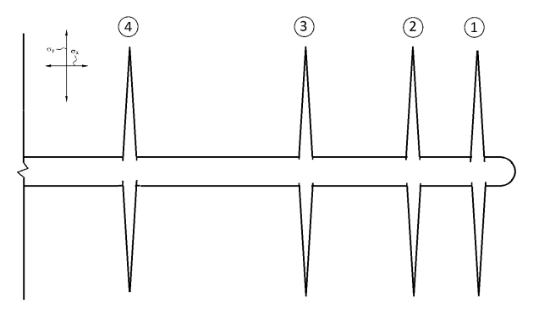
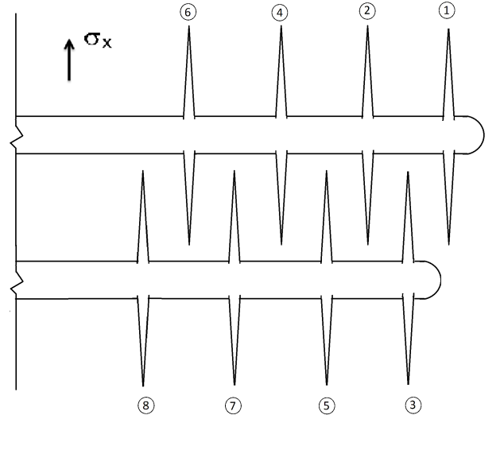
The process, developed by Texas Tech, is method for enhancing far field complexity in subterranean formations during hydraulic fracturing treatments by means of optimizing the placement of fractures along the deviated wellbores. In recent years, new fracturing designs and techniques have been developed and practiced to enhance production of trapped hydrocarbons. The new techniques focus on reducing stress contrast during fracture propagation while enhancing far field complexity and maximizing the stimulated reservoir volume. Zipper frac is one of these techniques which involve simultaneous stimulation of two parallel horizontal wells from toe to heel. In this technique, created fractures in each cluster propagate toward each other so that the induced stresses near the tips force fracture propagation to a direction perpendicular to the main fracture. The effectiveness of zipper frac has been approved by the industry; however, the optimization of the treatment is still under discussion. The results demonstrate that the modified zipper frac improves the performance of fracturing treatment comparing to the original zipper frac by means of increasing contact area and eventually enhancing fluid production. We also present a comparison of the two techniques with alternating fracturing in which fractures are placed alternatively starting from the toe of the horizontal wellbore and moving towards the heel.

Modified Zipper-Frac (MZF)
A new design in fracturing placement is developed to improve the stimulated reservoir volume (SRV) effectively. Similarly to zipper-frac, MZF can be applied in multi-lateral completions where two or more laterals will be fractured to create a complex network. As mentioned before, the domination of stress perturbation in zipper-frac design is limited to the area near the tips, while in MZF the area between fractures will be altered by stress interference caused by the middle fracture initiated from the other lateral.

With MZF, we take advantage of both concepts developed in alternating fracturing and zipper-frac to create more complexity in the reservoir. However, unlike alternating fracturing, MZF is simple to practice without needing special downhole tools. In this design, fractures are placed in a staggered pattern to take advantage of the presence of a middle fracture for each two consecutive fractures. The risks of stress reversal near the wellbore as well as well communication are minimal compared to the other designs. While MZF shows improvement in fracture complexity from a geomechanical viewpoint, it also shows promise in enhancing long term production of the reservoir from a fluid flow aspect. Modified zipper farc design can potentially increase the stress interference between the fractures and create an effective SRV to enhance hydrocarbon production.

Mohammed Soliman, Ph.D., Deparment Chair, Bob L. Herd Department of Petroleum Engineering, mohammed.soliman@ttu.edu / Lubbock, Texas 79409 / T: 806.742.---- / depts.ttu.edu/pe/

