Alternating Electrode Micro-cathode Thrusters for Nanospacecraft
Inventors: | Michael Keidar, Dereck Chui, Taisen Zhuang, Alexy Shashurin  School of Engineering & Applied Science, George Washington University
Field  Mechanical Engineering, Aerospace, Satellites | As the name suggests, nanosatellites and microsatellites are significantly smaller and lighter than traditional satellites (between 1 kg and 100kg). With this shrinkage, the demands for alternative propulsion systems as well as maximum fuel efficiency are extremely important. Pulse plasma metal electrode micro-arc cathode thrusters (µCAT) have emerged as a good alternative to chemical propulsion systems.  Pulse plasma micro-cathode thrusters use small bursts of electrical current to generate a plasma arc jet which propel the object forward. Plasma generation, however, results in gradual depletion of the cathode involved in the plasma burst formation, while the anode remains unused.  Researchers at the George Washington University have developed an alternating electrode micro-cathode thruster (AE-µCAT) which utilizes two different electrode materials which can alternate as cathodes and anodes. This extends the lifetime of the thruster as well as provides varying burst lengths (impulse-bits) to better control the satellite.  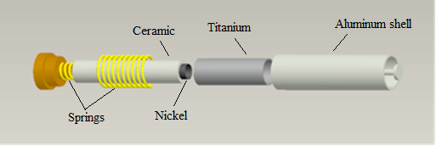  Figure. 1. An exploded view of the AE-µCAT
Objective
Seeking development and licensing partners

Applications: | - Deep space exploration  - Fine control of nano/micro satellites  - Personal or near earth nano/micro satellites
Advantages: | - Longer life for micro-cathode thrusters (Up twice as long)  - Alternating electrodes provide two types of plasma bursts instead of one in the conventional design
Patent Status: | Provisional Patent Filed
Contact: | Gus Williamson, Licensing Associate  Tel: +1-202-994-8975  Email: gwilliamson@gwu.edu

