Potential Market Opportunities

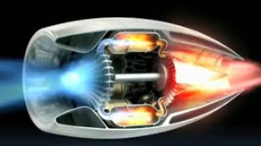

Efficient Atomizing Spray Nozzle

**Market Opportunity and Value Proposition**

Alternative energy solutions incorporating biofuels and application of high viscosity materials are two very challenging issues facing technology adoption for customers.

Spraying of high viscosity liquids can require high volume flow rates of air, delivered at high pressures to achieve the required droplet diameter. Current atomizers work at low efficiencies (high supply pressure for a given drop diameter) when atomizing viscous fluids. This nozzle can also be used for spray coating non-Newtonian fluids and polymers, such as those used in the pharmaceutical industry. Spray drying of biomaterials for sampling and preservation in the food processing industry is another application requiring high volume throughput, control of size distribution, and the ability to atomize unconventional materials.

Our atomizer configuration is based on a strong understanding of theory, and can be customized to produce droplets of a given diameter for a given viscosity. This degree of control is not possible using air-blast atomizers or the recently developed flow-blurring nozzles. The counterflow nozzle operates at much lower air flow rates (up to 50% reduction) and pressures than air-blast atomizers, reducing energy costs.

# Description of the Invention

Researchers at the University of Minnesota have developed a new atomizing nozzle design. The counterflow nozzle generates countercurrent shear by directing air upstream into the liquid stream, as opposed to standard designs involving co-flow. The nozzle can be operated in steady or pulsatile modes, with a tunable pulse frequency depending on application. The nozzle creates a finer mist and more uniform droplet diameter distribution than standard designs, and requires less air at lower pressure to achieve this. The strong theoretical foundation for this design allows the geometry to be tuned as a function of the fluid properties, allowing for operation with a range of viscosities to produce droplets of the required diameter at a given flow rate.

 

**Next Steps**

* Submitting grant proposals to NSF, ACS/PRF (American Chemical Society, Petroleum Research Fund)
* Seeking industry partners

# Potential Applications

* Fuel injection: use of residual and heavy fuel oils as replacements for lighter oils
* Spray coating of pills in pharma industry
* Spray painting with minimal air-blast
* Spray drying of foodstuff
* Spray cooling of hot surfaces in manufacturing

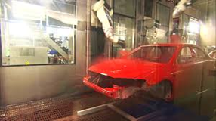

Technology Status

Prototype built.

Testing and characterization on-going.

IP Status

Patent Pending

Primary Inventor(s)

Alison Hoxie, PhD

Mechanical and Industrial Engineering

Paul Strykowski, PhD

Mechanical Engineering

Vinod Srinivasan, PhD

Mechanical Engineering

Contact

Kevin Nickels  
Technology Licensing Officer 612.625.7289 knickels@umn.edu

Case Reference

20150202

www.license.umn.edu