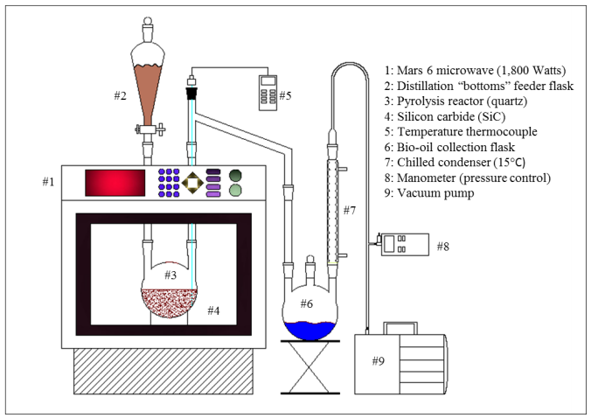

Technology Status

Proof of Concept.

IP Status

Patent Pending

Primary Inventor(s)

Roger Ruan, PhD

Bioproducts and Biosystems Engineering

Contact

Larry Micek   
Technology Licensing Officer  
612-624-9568  
[micek013@umn.edu](mailto:micek013@umn.edu)

Case Reference

20180117

www.license.umn.edu

Improving Biodiesel Production Efficiency via Methyl Ester Recovery

Biodiesel distillation is a reliable post-treatment method for removing multiple impurities to consistently produce commercial-grade biodiesel. The waste produced from biodiesel distillation, vacuum distillation bottoms (VDB), is a mixture of higher molecular weight methyl esters (84%) and derivatives. representing approx. 5-15% of the crude biodiesel. VDBs must either be disposed of or can be sold as low grade heating oil for boilers or ocean shipping. Producing biodiesel (methyl esters) from oils via transesterification or pyrolysis has yielded bio-oil containing a mixture of various compounds and requires additional processing (vacuum distillation) before it can be used as a transportation fuel, producing vacuum distillation bottoms (VDB) and causing significant yield loss.

# Description of the Invention

A new microwave-assisted pyrolysis (MAP) technology recovers valuable methyl esters from VDBs, solving the waste formation problem by recovering a significant amount (approximately 85% wt/wt) of the VDBs as a transparent bio-oil composed mostly of methyl esters. A MAP reactor with a fixed-bed heat susceptor silicon carbide (SiC) catalyst absorbs microwave radiation and quickly achieves a high temperature, rapidly heating VDBs and avoiding further dimerization and derivatization. Testing shows the bio-oil can be blended back into the initial distillate stream and that it passes all ASTM D6751 tests required for commercial biodiesel. The process is easily integrated into existing biodiesel processes and can increase biodiesel yield, resulting in more biodiesel sold than low grade heating fuel.

# Features and Benefits

* Up to 10% increase in biodiesel yields for any commercial biodiesel producer
* Decreases waste stream from biodiesel production
* Recovers valuable methyl ester from biodiesel vacuum distillation bottoms (VDBs)
* Employs energy efficient microwave-assisted pyrolysis (MAP)
* Robust, cost effective, fixed-bed heat susceptor silicon carbide (SiC) catalyst
* Minimizes dimerization and derivatization; rapid heating maximizes yield
* Produces biodiesel that passes ASTM D6751 tests when blended into conventional bio-diesel
* High temperatures required for biofuel distillation can be sustained

# Potential Applications

* Biodiesel production and purification